| Insert a photo of your favorite roller coaster | Space Mountain POV Walt Disney World (Warning: TW Flashing Lights) - YouTube |
| --- | --- |

| Explain why the economy is like a roller coaster | The national economy fluctuates resulting in periods of boom and goes up and down because of a roller coaster.When we are in a recession there is cyclical unemployment |
| --- | --- |

| What is the most concerning problem for an economy that is in recession? | There is really low unemployment but price levels are going up. High rates of unemployment. |
| --- | --- |

| What is a big concern for an economy that is producing beyond full-employment? | An economy that is above full employment is a cause for concern as it may lead to inflation. If it is going slow then unemployment, if itis going fast then |
| --- | --- |

| What government entity carries out discretionary fiscal policy? | Congress |
| --- | --- |

| What is “Disposable Income”? | The amount of money a person has available to spend after taxes  Congress can increase or decrease people’s disposable income through fiscal policy |
| --- | --- |

| What are the two tools of discretionary fiscal policy? | a)Government spnd(& transfers)  b)taxation |
| --- | --- |

**Expansionary Fiscal Policy**

| Expansionary Fiscal Policy is like the of a car | It is like an accelerator of a car |
| --- | --- |
| What problem would have to be present for expansionary fiscal policy to be appropriate? | When we need to spend money for our government spending and decrease taxes . They need do reduce low unemployment rate and GDPr. Speed up the economy if it is slow |

| What could Congress do to taxes in order to stimulate the economy? | Decrease taxes |
| --- | --- |
| Explain why this would stimulate the economy | Our money wouldn’t go to the government, but would go to companies, which would use the money reinvesting workers. Less taxes that need to be paid for the government would be used in |
| Insert a photo of something that your family might spend money on if the government significantly lowered taxes | Recreational vehicle - Wikipedia |

| What could Congress do to government spending in order to stimulate the economy? | Increase Government Spending(& transfers) |
| --- | --- |
| Explain why this would stimulate the economy | This increase in spending helps the company that receives this payment. This received money will get spent at another business. This 2nd business now has more money.It will spend this money |

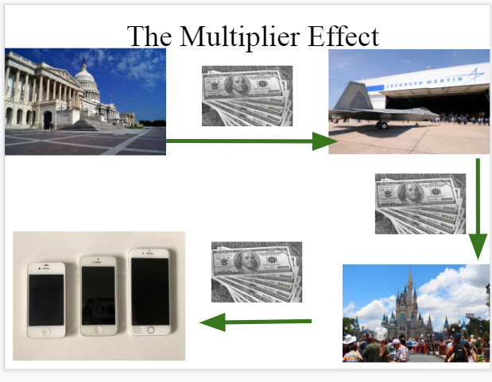

| Explain the Multiplier Effect diagram above | How much a change in tax rates or a change in spending can impact GDP is much greater than the initial amount  For example,  A $4 billion tax cut will increase GDP by much more than just 4$ billion  A $4 billion increase in gov’t spending will increase GDP by much more than just $4 billion |
| --- | --- |

**Contractionary Fiscal Policy**

| Contractionary Fiscal Policy is like the ___ of a car | It is like the breaks of the car |
| --- | --- |
| What problem would have to be present for contractionary fiscal policy to be appropriate? | Our economy is going too fast, we will crash, unemployment levels are too fast. It is going to fast low unemployment and high inflation |

| What could Congress do to taxes to slow down the economy? | Increase Taxes on consumers. |
| --- | --- |
| How could this slow down the economy? | If you increase taxes on consumers, inflation will go up and high inflation slows the economy, it will increase inflation, and decrease GDPr. If you do this then encourages businesses to hire more people and there will be a low unemployment rate, low unemployment rate high inflation, you want them to be fluctuating.Decreases individual disposable income.Decrease spending so low inflation |

| What could Congress do to government spending to slow down the economy? | Decrease Gov’t spending (and transfer) |
| --- | --- |
| Explain how this could slow down the economy | If you decrease gov’t spending it reduces inflation, and decreases GDPr. If you decrease government spending , unemployment rates go up. |

**Summary**

| In a multiple sentence paragraph, explain why the economy is like a car | The economy is like a car because it slowly fluctuates in the speed like a car, when driving you should drive at a not to fast and not to slow speed, like how you |
| --- | --- |

| In a multiple sentence paragraph, explain why the economy is like the story “Goldilocks and the 3 Bears” | Goldilock and the 3 bears got an equal amount of honey, like hoe we need to have not to much or not to less of inflation and unemployment, higher the prices the lesspeople will buy less. You also need to think about your actions in spending how it can hurt you and the other arounds you , if you spend to much then there’ll be inflation, if you spend less low inflation and high unemployment. |
| --- | --- |